TASK 3 - Country-Wise-Netflix-Content-Analysis

First Visualization output:
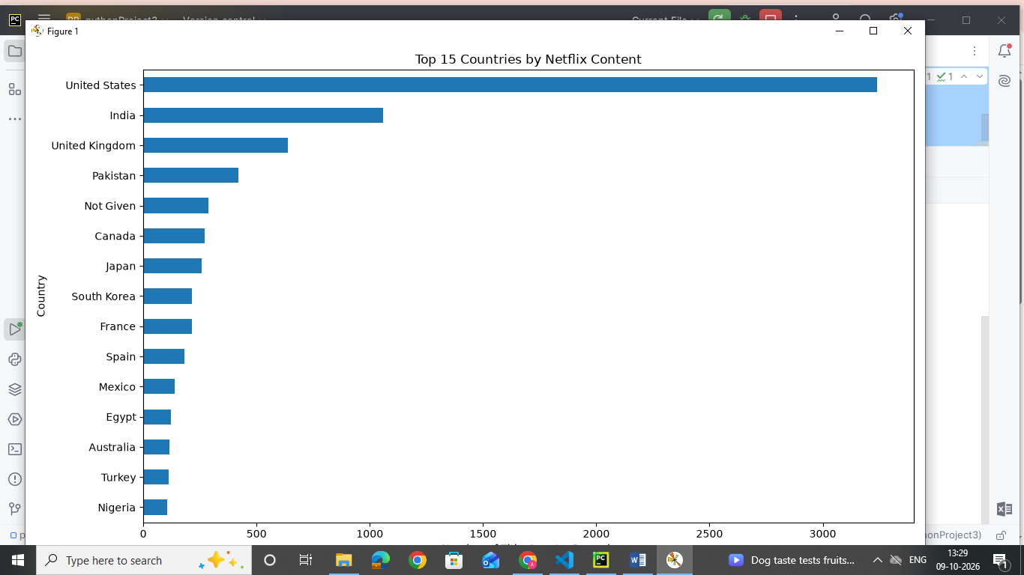
Second Visualization output:
